Congratulations

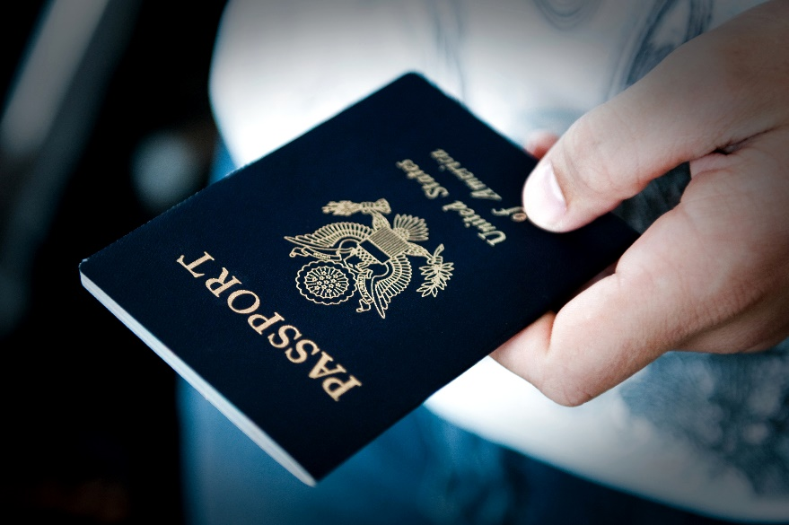
New passport

- Apply in person using form DS-11
(instructions at https://travel.state.gov/content/travel/en/passports/need-passport/apply-in-person.html)

- Get your passport photo taken – There are specific passport photo locations, and some passport acceptance facilities can take photos (call first to confirm).

CVS and Walgreens both take passport pictures for $16.99, but call first to make sure the location you are going to actually has that capability, and the person that knows how to do it will be there.

- Follow instructions for required documentation proving citizenship and identity.

- Use the enclosed check written to ‘"U.S. Department of State" to submit your application fee. Use the $35 enclosed cash to pay the execution fee at the passport acceptance facility based on the payment type they will accept.

- Submit application and documents in person at passport acceptance facility. Find a location and make an appointment: https://iafdb.travel.state.gov/

